CST 415 – Lecture 4
Wilsonville, Fall 2017

CNP 4; ICN, 11.1, 12.1-12.3: Transport Layer, TCP, UDP
Nice to Read: ICN 6, 7.7-7.10, 11.1.x – 11.2

Transport Layer
Layer 4, Transport – Ensures data is reliably moved from machine to machine
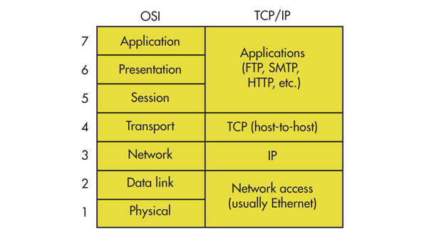
For the Internet, Layer 4 protocols include UDP, TCP, ICMP, and others

Note: SDU, Service Data Unit, term used by CNP tesxt for an arbitrary unit representing a complete request or response for a given service, meaningful to the users of the service

Segment – Unit of data sent through Transport layer

Challenges for the Transport layer:
- Loss – data does not arrive at destination
- Corruption – data arrives, but it is different from what was sent
- Reorded – data arrives in a different order from what was sent
- Duplicated – parts of the data are duplicated in transit
- Overflow –other layers too fast/slow, causes data to collect in queues

Reliability

For a reliable Transport layer, must have two types of segements:
- Data Segment – Used for sending data from machine to machine
- Control Segment – Used for controlling the flow of data
Ideal transport over ideal network, including acknowledgement control segments (acks):

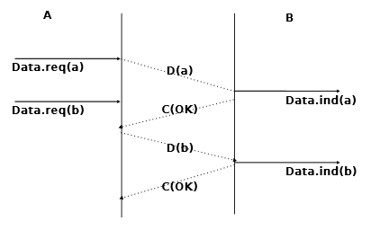
- CNP 4.1.1, Pg. 70

Data.req( ) – Request to send data
Data.ind( ) – Indication that data has arived
D( ) – Data segment
C( ) – Control segment, OK means data arrived successfully

Note: Even in the ideal network case, we need control to deal with overflow conditions

Dealing with troubles in the Network layer:
- Segments can be corrupted by transmission errors
- Segments can be lost
- Segments can be reordered or duplicated

Segment Corruption

Segments are separated into Header and Payload
Header includes a Check Sum or CRC (Cyclic Reduncancy Check) to detect errors
When an error is detected, the segment is discarded (and must be resent)
Corrupted packets are not Ack’d

Segment Loss

Retransmission timers – set to longer than round-trip-time, retransmit if no Ack in time
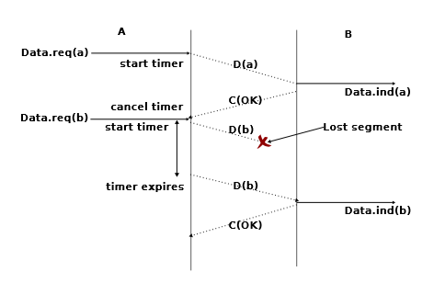
- CNP 4.1.2 Pg. 72

But what if the Ack is lost?
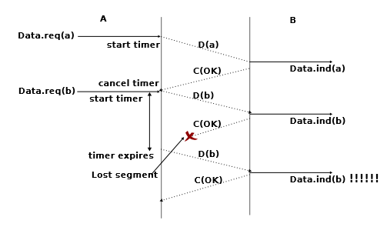
- CNP 4.1.2 Pg. 72

Use a sequence number in the header to ensure segment b is not duplciated
If every segment must be Ack’d before next is sent, dramatically cuts speed of network

Pipelining allows several segments to be sent before receiving the first Ack
Sliding Window represents those sequence numbers that can be sent

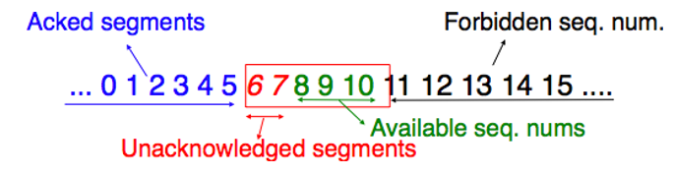
- CNP 4.1.2, Pg. 75

Sliding Window size is negotiated between sender/receiver

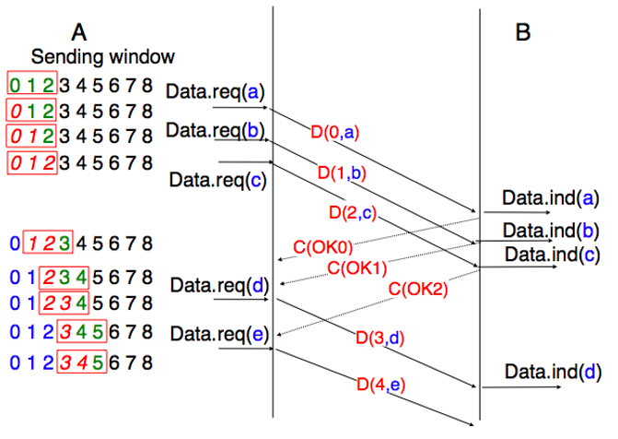
- CNP 4.1.2, Pg. 75

When segments are lost, must retransmit using scheme to decide when/what to retransmit

Go-Back-N scheme – only accept segments in sequence, back up window to last in-order segement and force retransmit from that point forward

Selective Repeat scheme – accept segements as long as they are in the window, Ack any that are received and re-request any that seem to have been skipped
Selective Repeat in operation:
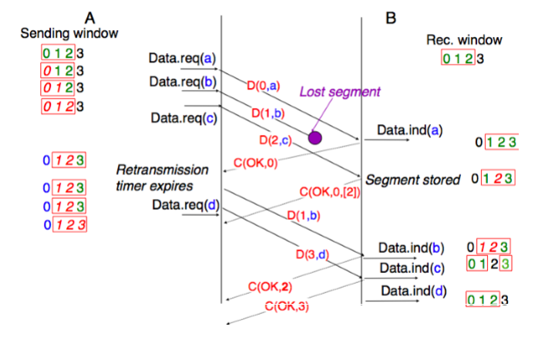
- CNP 4.1.2, Pg. 78
Segments Reordered / Duplicated

Mostly handled with sequence numbers and window size
Delay in sending/receiving could cause sequence numbers to roll over
MSL, Maximum Segment Lifetime, significantly delayed packets are discarded

Piggy-backing allows data and control to travel in the same headers
Allows Data/Ack to folow in both directions seamlessly

To the client of the Transport Layer, send/receie looks like Byte Streams
Send a sequence of bytes, receive a sequence of bytes
In the Transport Layer, bytes are grouped into segements which are…
Sent, Ack’d (or not), Resent, etc.

Connections

Established between client/server to ensure that data is delivered to the correct end point
Negotiated with connection requests and accepts
Transport Clock used to ensure that duplciate requests are not processed
Three-way Handshake for connections prevents duplicates:
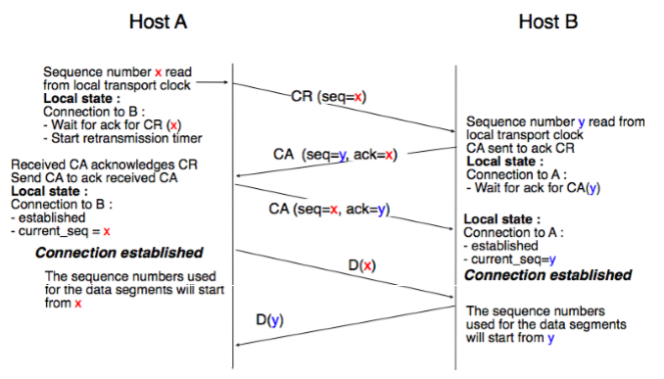
- CNP 4.1.2, Pg. 84
CR – connect request; CA – connect accept
Connection requests will be rejected if the sequence numbers are not properly Ack’d

Release
Abrupt Release – Connection considered released as soon as Disconnect request sent, can cause loss of data as the receiving side may not have finished sending it’s data

Graceful Release – Both sender and receiver release as soon as they are done sending any segements remaining in their queue

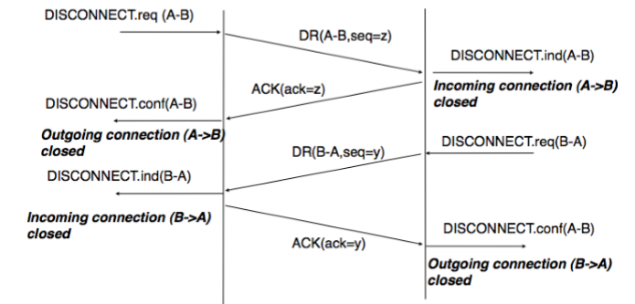
- CNP 4.1.2, Pg. 87

UDP
User Datagram Protocol

Connectionless, delivery and order are not guaranteed
But, at least segments won’t be corrupted. Yay!

Primary advantage to using UDP (Transport Layer) over pure IP (Network Layer) is the addition of port numbers to identify a service running on a host
IP will deliver a packet to a node, identified by IP address
UDP will deliver a segment, possibly spread over multiple packets, to a service by Port
Both sender and receiver will have a port number for their end of the conversation

UDP Segment Header:
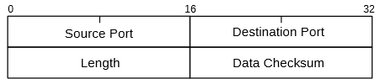
- ICN 11.1, Pg. 269

Followed by data in the remainder of the segment

UDP is most useful for applications that require very low overhead, maximum throughput and can correct for dropped packets at the application layer

RPC, NFS and VoIP are examples of higher level protocols that use UDP
RPC – Remote Procedure Call
NFS – Network File System
VoIP – Voice over IP

For applications that require guaranteed delivery, in order, TCP is the best choice…

TCP
Transmission Control Protocol

Connected, guaranteed delivery and in-order
Most applications use TCP on the internet, including mail (SMTP) and web (HTTP)

“I’d tell you a UDP joke, but you might not get it.”
“I always get TCP jokes.”
http://etherealmind.com/corny-network-engineer-jokes/

TCP Segment’s include a Header and optionally a Data portion
Header (at least 20 bytes long):

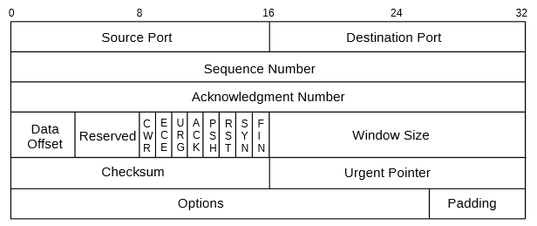
- ICN 12.2, Pg. 297
Fields:
- Source Port: Port for service that is sending the data
- Destination Port: Port for service that is receiving the data
- Sequence Number: Position of the first data byte in the overall data stream
- Acknoledgement Number: Next sequence number expected from the other side
- Data Offset: Length of the TCP header
- Flags: Various flags indicating control coded in the header …
SYN, ACK, FIN are the most common (see more below)
- Window Size: Size of sliding window for reliability
- Checksum: Checksum of the entire segment, including header
- Urgent Pointer: Which parts of data are “urgent” (not used much today)
- Options/Padding: New info since the protocol was first defined

Note that the TCP header does NOT include the IP addresses
That’s because those are in the IP header that comes before this

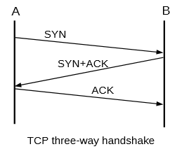
TCP Connect

Three-way hand-shake to ensure connection:
- Client sends SYN to Server
Requests connection to specific port
- Server replies with SYN and ACK
Indicating server allocated port for socket
- Client replies with ACK
Acknowledging connection

Data may now flow between client and server

- ICN 12.3, Pg. 298

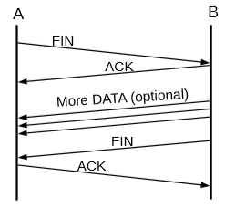
TCP Close

Graceful close of connection:
- Client sends FIN to Server
Requesting closure of connection
- Server replies with ACK
Acknowleding client side close
- Server sends remaining segments to Client
Clearing out the server side buffer
- Server sends FIN to Client
Indicating Server is closing connection
- Client sends ACK to Server
Acknowleding Server closure

- ICN 12.3, Pg. 299
Example Full Conversation

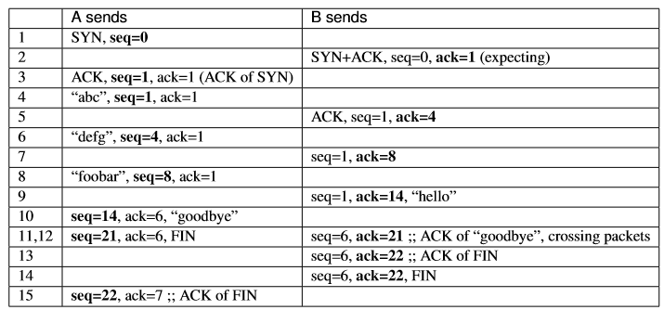
- ICN 12.3, Pg. 300
As a diagram, this looks like…

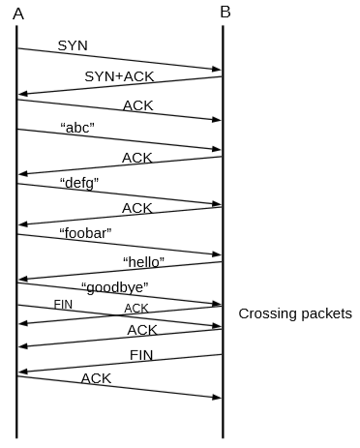
- ICN 12.3, Pg. 300

The TCP sequence numbers never start at 0 (zero)
Actually start with an ISN – Initial Sequence Number
Each side chooses it’s own ISN and the ACKs for the SYNs confirm this choice

Wireshark
To see conversations like this in action…
https://www.wireshark.org/

As they say on their home page:
Wireshark is the world’s foremost and widely-used network protocol analyzer. It lets you see what’s happening on your network at a microscopic level and is the de facto (and often de jure) standard across many commercial and non-profit enterprises, government agencies, and educational institutions. Wireshark development thrives thanks to the volunteer contributions of networking experts around the globe and is the continuation of a project started by Gerald Combs in 1998.

And it’s free! It’s provided under the GPL. From Wireshark’s FAQ:
The license under which Wireshark is issued is the GNU General Public License version 2. See the GNU GPL FAQ for some more information.

